**DIGITAL FIDGETER  
  
BRIEF DESCRIPTION**The Digital Fidgeter features a physical fidget cube like device that is connected to a computer and a program that is simulating a room. The actions you complete on the cube will correspond with an element within the room.

**INSPIRATION**  
I got the idea from room designer games I used to play when I was a kid.  
I loved to take the time to customize the rooms to my liking with a bunch of details and items. Once the customizing phase was other though, I was bored and a bit disappointed because now that I built my room, there was nothing to do with it now, no interaction, no actual use of the room.   
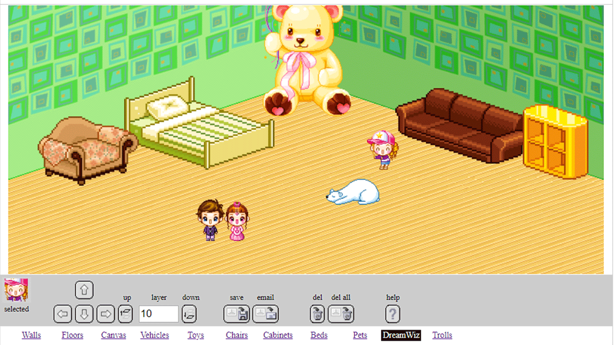

The Digital Fidgeter will have room customization users can select from. There will be interaction of the items within the room.

The interaction portion is inspired from an actual fidget cube.  
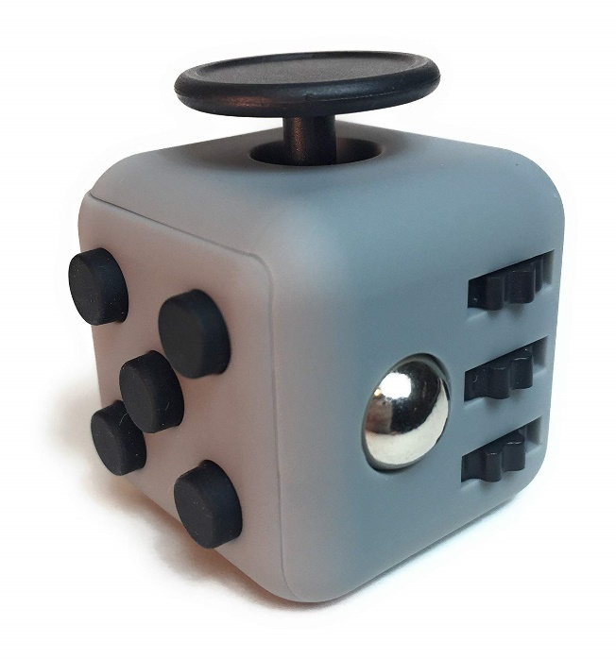  
I really like the idea of the fidget cube, having various different motor activities on the cube for users to mess around with. And for the room interaction I thought it would be really cool to have a hardware physical interaction with the room instead of clicking and keyboard typing.  
  
**TECHNOLOGY AND HARDWARE**For this project I plan to use P5js to code entire project. I need to do some research about hardware coding, but I think P5js has the capacity to interact with hardware. I plan to use an Arduino board to connect the physical hardware together and connect it to the computer. I will also be using a starter hardware kit that has motors and sensors to create the physical fidget cube that will be connected to the Arduino board.  
  
**PRESENTATION**When presenting the project, I will just need a table extra to the typical setup for presentations. I will have my laptop that will have the program (which has HDMI) to present the digital room and a table setup to place the physical cube on for people to interact with.  
  
**KNOWS**I’m confident in the room creation and setting up the seen for the digital screen; the room setup, the user interaction with choosing the items in the space and the drawing of the room space.

**UNKNOWNS**All of the hardware component. I’ve always wanted to learn how to use hardware with Raspberry Pi and Arduino but I never got around to playing around with the equipment. I’m excited to learn about coding the sensors and linking the physical to the digital.

**PORTFOLIO**I want to hopefully put this project up onto a website (but first I have to create the website itself) and also my art Instagram. I love creating things and I want to share with the world the things I create. So a way to showcase my work is through social media like instagram and a website. For now the project will go on the tumblr and transition over once I’ve created my website (Which I’ve been learning a lot about how to make in this class!)

**SCHEDULE**12.4/12.6 – I hope to have the digital space complete. This includes the assets for the room, the customization of the room and the interaction to select those customizations.  
I also hope to have all my research about Arduino and hardware done and have at least 1 physical interaction working with the digital screen.